DriveSafe Advocacy

An ADWEB Project

Presented to The Faculty of the

School of Computing



In Partial Fulfillment

of the Requirements for the Course

Advanced Dynamic Web Applications (6ADWEB)

Patrick C. Villanueva

April 2024

**Table of Contents**

Page

Cover Page i

Table of Contents ii

1. **Introduction**

Introduction 2

Problems/Issues 2

Objectives 2

Flowchart ……………………………………………………………...…………… 3

1. **Application Design**

Application Mockup Proposal 3

Project Plan and Schedule (any chart scheduling tool) 4

1. **Application Deployment**

Video Presentation and Demonstration 4

**IV. Meetings Documentation**

1. **Introduction**

Introduction

Welcome to DriveSafe Advocacy! Our goal is to ensure that every driver drives safely. The goal of our website is to simplify and make driving safer for all users. Regardless of your driving experience, we offer guidance and recommendations to ensure the safety of both you and other road users.

The number of accidents on the streets is increasing daily. For everyone, it's hazardous and scary. We are here to discuss the issues and provide you with solutions because of this. We'll teach you how to be safe and drive better by avoiding distracted driving and other dangerous driving habits.

Our mission at DriveSafe Advocacy is to increase road safety for all users. We think that by cooperating and exchanging important data, we may prevent accidents and save lives. Thus, let us begin our joint path towards safer driving!

Problems/Issues

Multiple problems might limit the DRIVESAFE ADVOCACY website's ability to effectively promote road safety. Limited accessibility is a major problem since the website might not be user-friendly for people with disabilities, which could mean that some audience members are not reached. Furthermore, there may be issues with device compatibility, where users on mobile devices or with various web browsers may not be able to fully utilize the website due to its form and functionality. In addition, the absence of multilingual assistance limits the website's accessibility and inclusivity, which could turn off non-English speaking visitors who could find the content useful. In order for the website to successfully interact with a ranged audience and accomplish its goal of encouraging safe driving practices, it is important that these challenges be resolved.

Objectives

The DriveSafe Advocacy website aims to raise awareness of road safety issues and promote safe driving practices using a variety of methods. First and foremost, the website aims to raise awareness by offering educational content on common road safety issues like an increase in accident rates, distracted driving, reckless behavior, and misinformation. Second, by

providing useful tools, advice, and recommendations, it aims to encourage safe driving practices among drivers of all skill levels. The website also aims to attract a wider audience by providing bilingual support and encouraging participation from other communities. The website strives to quantify its influence and success in promoting road safety, ultimately leading to safer roads and communities, by encouraging community interaction through interactive elements and frequent updates.

Flowchart

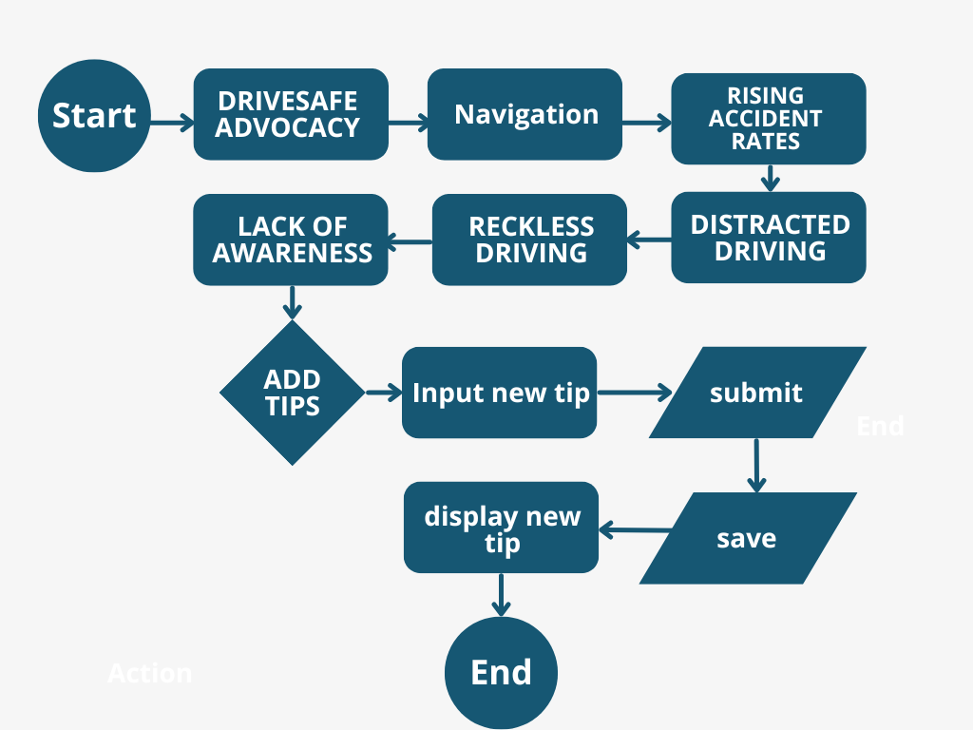

1. **Application Design**

Application Mockup Proposal

Project Plan and Schedule

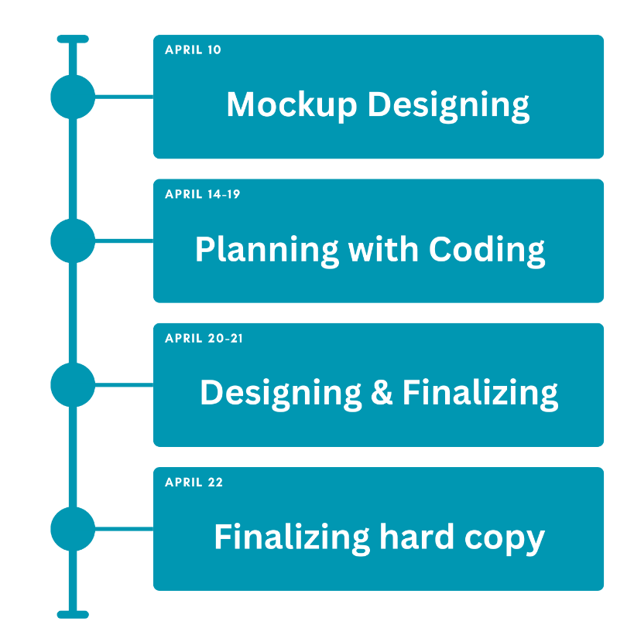

1. **Application Deployment**

Video Presentation and Demonstration

<https://drive.google.com/file/d/1QlFxoz-o1jRChpjA05Fn-Vu5sTfAtwtp/view?usp=sharing>

1. **Meetings Documentation**



